Electrocatalytic Oxygen Evolution with an Immobilized TAML Activator

Ethan L Demeter1, Shayna L Hilburg2, Newell R Washburn3, Terrence J Collins3, John R Kitchin1*

Carnegie Mellon University, Departments of Chemical Engineering1, Materials Science and Engineering2, and Chemistry3, 5000 Forbes Ave Pittsburgh PA 15213

**ABSTRACT:** Iron complexes of tetra-amido macrocyclic ligands are important members of the suite of oxidation catalysts known as TAML activators. TAML activators are known to be fast homogeneous water oxidation (WO) catalysts producing oxygen in the presence of chemical oxidants e.g., ceric ammonium nitrate (CAN). These homogeneous systems exhibited low turnover numbers (TON). Here we demonstrate immobilization on glassy carbon and carbon paper in an ink comprised of the prototype TAML activator, carbon black and Nafion and the subsequent use of this composition in heterogeneous electrocatalytic WO. The immobilized TAML system is shown to readily produce O2 with much higher TONs than the homogeneous predecessors.

Efficient energy storage is an important challenge in the further implementation of renewable energy generation to cope with the challenges of intermittency and peak production/demand mismatch. The formation of reactive chemical bonds has been one widely explored energy storage strategy for direct utilization or further conversion into liquid fuels. With its potential for an environmentally benign globally applicable process, the electrochemical splitting of water is a coveted target that couples the hydrogen and oxygen evolution reactions, HER and OER, respectively.1 The OER is the demanding challenge. It requires four electron transfers and accounts for most of the commonly observed overpotential. It occurs at highly oxidizing potentials that jeopardize material stability. OER catalysis has been of particular interest lately, with promising studies involving thin transition metal oxide films2-8 and transition metal complexes.9-14 Metal oxide catalysts have been extensively investigated;

15-18 however, hypothesized correlations between the energetics of the distinct steps result in limitations of the minimum overpotential necessary for high rates of water oxidation.19 There is a critical need for new classes of OER catalysts that could circumvent the limitations inherent in metal oxide catalysts. Molecular electrocatalysts can offer a path to this goal by combining active centers with ligands that direct the reactivity.

Developing economical water oxidation catalysts is also of great interest where iron is of particular interest. Not only is iron one of the most abundant surface elements, it is widely deployed in enzymes for oxidation catalysis, as it can readily change its oxidation state, which makes it an attractive catalyst material for synthetic redox processes.20 Iron oxides are not particularly efficient water oxidation electrocatalysts, although iron promotes other metal oxide based electrocatalysts.21 Water oxidation by iron complexes has been sparsely demonstrated to date

22-24 using chemical oxidants such as CAN or Ru(bpy)33+ to drive O2 evolution.

Iron TAML activators have recently been shown to catalyze the homogeneous OER driven by CAN.23 TAML activators are the first full functional mimics of oxidizing enzymes and have been demonstrated to catalyze myriad oxidations by peroxide, especially in the oxidative destruction of water contaminants.25-27 Here, the prototype TAML activator **1** (Figure 1) has been used as an electrocatalyst for the OER. Under homogeneous conditions, **1** displays peak peroxide activation at pH 9-11 and turnover number of order 103 in the bleaching of Orange II dye.28 We attempted to use **1** as a homogeneous electrocatalyst by electrolyzing a solution containing TAML, but no evidence of electrocatalytic activity was observed (see Supporting Information). However, we found that supporting **1** on an electrode resulted in an active heterogeneous electrocatalyst for the OER as previously claimed would be the case.29



Figure 1. The prototype TAML activator, 1.

TAML/C electrocatalyst powder was produced by combining **1** (20 mg) in water (1 mL—briefly sonicated to ensure dissolution), with Vulcan XC-72 Carbon Black (**CB**, 1 g) serving as the catalyst support. The resulting slurry was sonicated (1 hr) and was then filtered, washed (with DI water), dried, and collected. The catalyst ink was prepared by mixing the **1**/C electrocatalyst powder and Nafion binder (8 wt%, Aldrich) in a methanol/isopropanol mixture (1/1 by volume, 5 mL). After sonication, the catalyst ink (20 L) was deposited onto either a 3 mm glassy carbon disk electrode (Pine Instruments) or a Toray carbon paper (1 cm2). The wet electrodes were placed into a 120 °C oven until dry. For the carbon paper electrodes, additional applications of ink were applied until the desired dry weight of the catalyst was achieved.

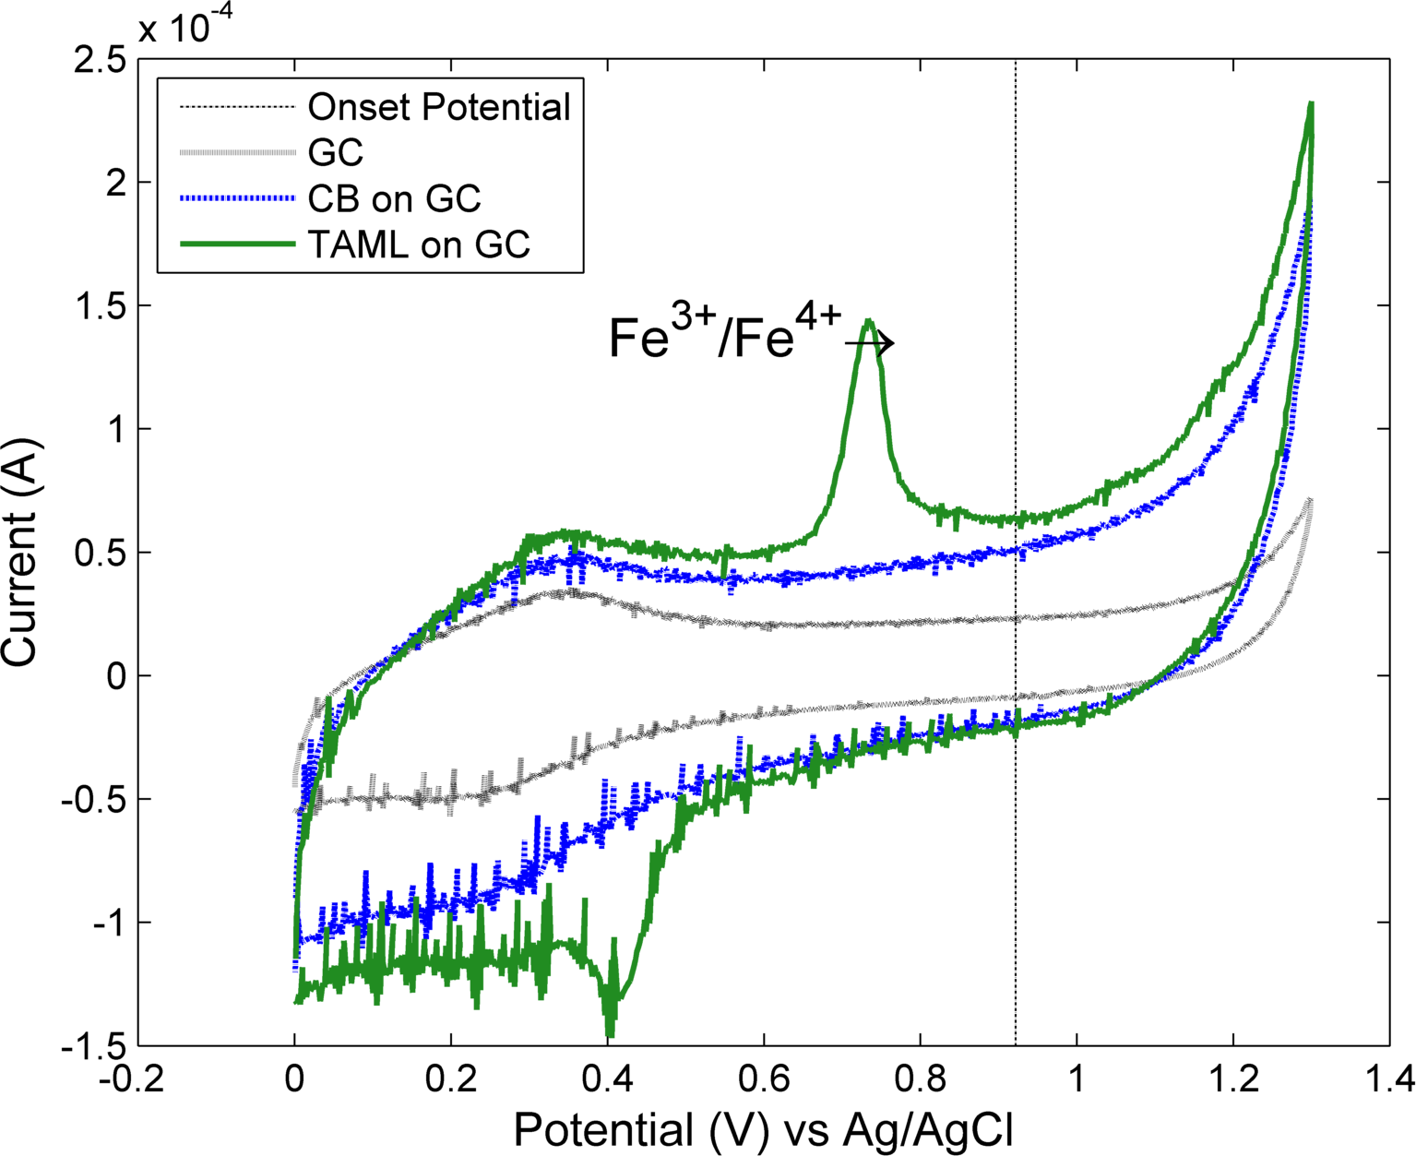

Figure 2. Cyclic voltammograms for clean glassy carbon (GC), and GC coated as described with 20 μL XC-72 carbon (GC- CB), and 20 μL catalyst ink (GC-Ink-1). Conditions: scan rate 100 mV/s, electrolyte HNO3 (0.1 M), T=298 K, vs. Ag/AgCl reference, Pt counter electrode.

Cyclic voltammetry (CV) and constant current electrochemical experiments were performed using a Gamry Ref600 potentiostat, in 0.1 M HNO3, a Pt wire counter electrode and an Ag/AgCl reference electrode. The counter electrode was housed in a glass compartment with a glass frit that allows evolved H2 to escape to the atmosphere. The OER experiments were performed in a gas-tight cell equipped with a FOXY fluorescent oxygen sensor from Ocean Optics. A Shimadzu GC-8A gas chromatograph was used to evaluate the gas composition of the headspace using 0.1 mL gas samples. Previous uses of the fluorescent O2 sensor in this general area have been carried out in O2-free environments using a vacuum apparatus to evacuate the cell before backfilling with inert gas.30 In this work, the concentration of O2 above the ambient atmospheric concentration was measured. This adaptation provides the benefit that the amount of oxygen produced cannot be overestimated by air leakage into the cell. In contrast, in long experiments, the amount of oxygen produced can only be underestimated as a consequence of oxygen leakage from the cell. A baseline measurement of O2 was established in the cell prior to the electrochemical experiments and was subtracted from the electrocatalytic data for clarity.

The electrochemical results are summarized in Figures 2 and 3. Figure 2 presents CV data comparing the electrochemical behavior of the GC-Ink-**1** electrode with that of the polished GC and GC-CB electrodes. The GC-Ink-**1** inkloading of 20 μL corresponds to ~17 nmoles of **1**. The iron oxidation state in **1** is III and **1** has been shown to undergo an Fe+3/+4 oxidation, which can lead to the well-characterized (FeIV)2O dimer in homogeneous solution.31 Based on the CV data for the GC-Ink-**1** electrode (Fig. 2), a similar oxidation process is observed electrochemically, with the FeIII/IV process occurring at 720 mV (vs Ag/AgCl) prior to the onset of O2 evolution at ~1 V. Comparing the CVs, it is clear that this oxidation wave is not present in the absence of **1**. The CVs of Figure 2 also indicate comparative activity and here it can be seen that at a given overpotential (η> ηonset), the anodic current is higher with **1** present.

Figure 3 shows the real-time production of O2 gas as measured by the oxygen-selective FOXY probe. A constant current of 5 mA was applied for the experiment. O2 was evolved for the entire duration of the experiment up to a maximum of ~44 μmol. The empirical Faradaic efficiency was found to be ~45%; this value is a lower bound because evolved O2 can leak from the reaction cell due to the partial pressure of O2 in the cell being greater than that of ambient air.

A series of control experiments were performed to determine whether or not the O2 production described above is tied to **1** or if it resulted from the presence of iron in the ink. FeCl3 and FeIIICl(OEP) (OEP = 2,3,7,8,12,13,17,18-octaethyl-21H,23H-porphine, Aldrich) were supported on carbon black and painted onto carbon paper as described for **1** and the modified GC-Ink-FeCl3 (SI) and GC-Ink- FeIIICl(OEP) (Figure 3) electrodes were tested as OER electrocatalytic compositions. Gas analysis was performed during constant current electrolysis experiments to determine the products formed. GC and FOXY analyses indicated that O2 was not evolved in either of these two controls, but CO2 was formed. These results reinforce the conclusions derived above that **1** is electrochemically active in the GC-Ink-**1** electrode and is an effective OER electrocatalyst.

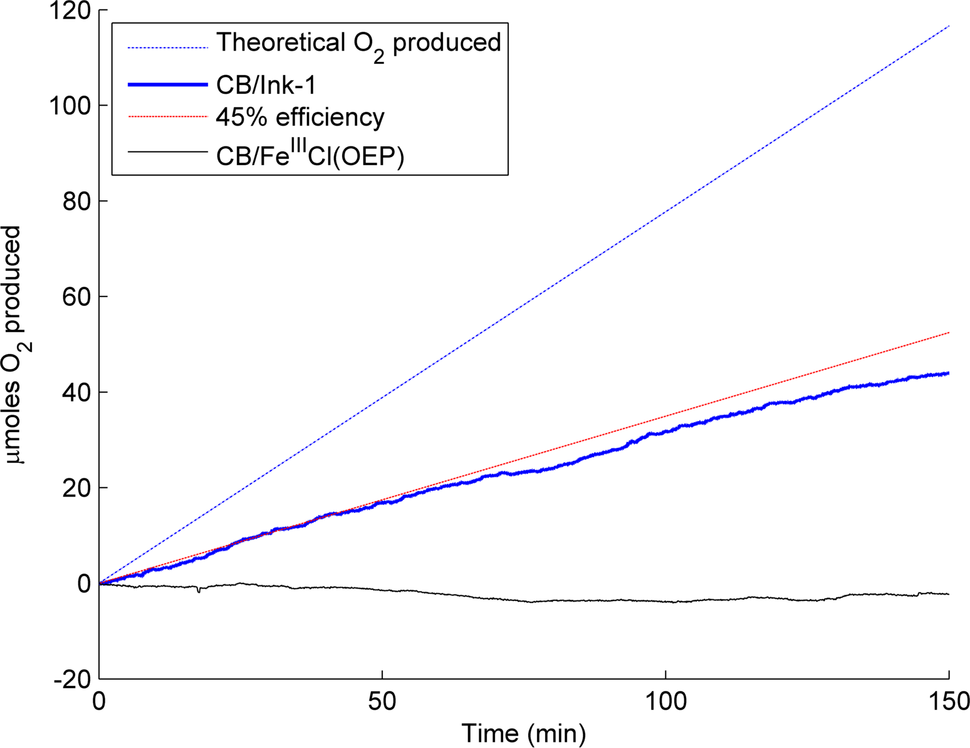

Figure 3. Real-time production of oxygen gas measured by a FOXY probe during 5 mA constant current experiments. Conditions: 0.1 M HNO3 . Dark blue line, 1 cm2 carbon paper electrode loaded with 2 mg catalyst ink (dry weight) containing TAML 1. Thin black line, 1 cm2 carbon paper electrode loaded with 2 mg catalyst ink (dry weight) containing FeIIICl(OEP) porphyrin. Both electrodes contained approximately 72 nmol of Fe.

The upper bound of the catalytic activity of 1 can be estimated in the form of turnovers if it is assumed that 1 is the electrocatalyst responsible for all of the oxygen produced (as noted above, about 45% of the current flow can be accounted as generated O2). Evaluating the turnover frequency at 50 minutes where the oxygen production is still linear leads to an estimate of 0.081 s-1. The slight decrease in the rate past this point is likely due to dilution by CO2 production. The turnover number achieved here represents a large increase compared to the experiments with the chemical oxidant.23

The composition of the headspace in the electrochemical cell was determined before and after constant current experiments on the GC-Ink-**1** electrode using gas chromatography (see Supporting Information). The peaks were quantitatively fit and the compositions were calculated by comparison to calibration gas data (SI). These GC data corroborate the principal findings obtained from the FOXY O2 probe experiments, specifically that O2 is produced above ambient air compositions during the electrolysis and that the additional current arose from production of CO2. There are three possible sources of CO2: oxidation of the organic ligand of **1**, the Nafion binder, or the carbon support material.

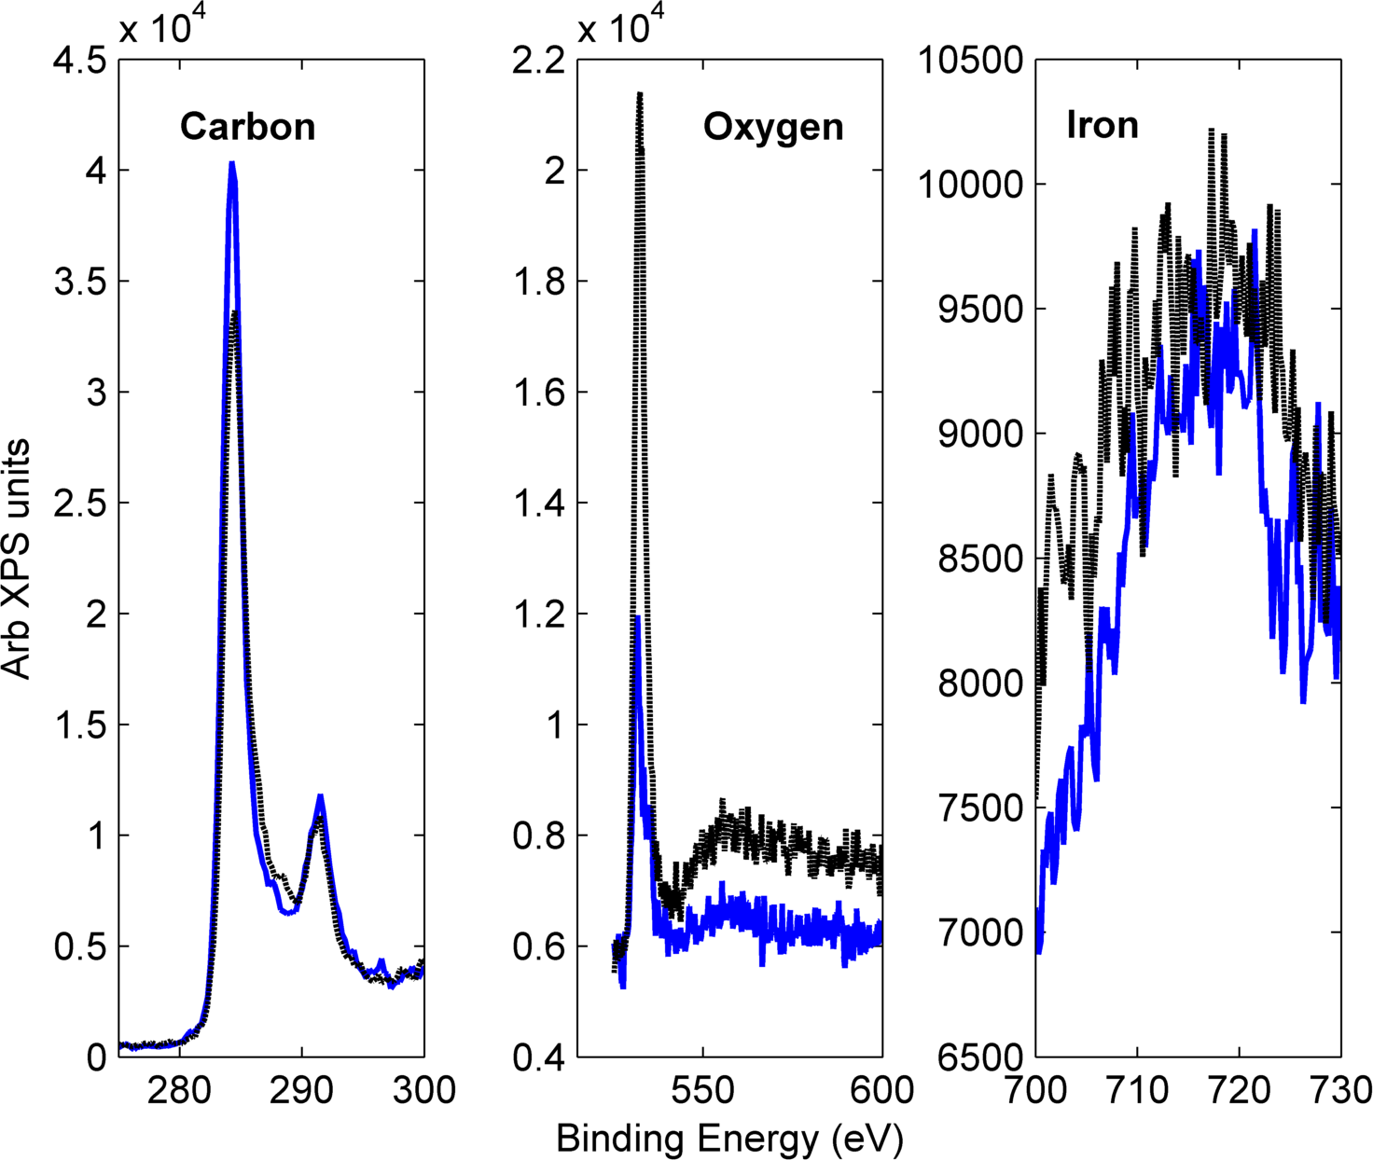Figure 4. XPS data of **1**-modified electrodes pre **(solid blue)** and post **(dashed black)** electrolysis experiments.

X-Ray photoelectron spectroscopy (XPS) experiments probing carbon, oxygen and iron were performed on the carbon paper electrodes before and after the OER experiments (Figure 4). Major differences can be seen in the oxygen and carbon but not the iron spectra. There are two carbon peaks present in the spectra, with the higher binding energy peak at ~291 eV attributable to carbon atoms near strongly electron-withdrawing elements as in Nafion. The decrease in the lower energy peak generally ascribable to CB or the carbon paper indicates that CB and/or carbon atoms from the carbon paper were oxidized and released as CO2 while the lack of a change in the 291 eV peak indicates that Nafion oxidation did not contribute to CO2 formation. The oxygen spectra show a large increase in intensity after the electrolysis experiments suggesting that the release of CO2 is a multi-step process involving surface carbon oxidation. The broad XPS peak for iron at 700–730 eV exhibits a similar appearance in both the unused and used electrodes, further suggesting that CB and/or the carbon paper is oxidized during electrocatalysis rather than the organic framework of the strongly donating macrocycle in **1**.

In conclusion, we have demonstrated the use of the TAML activator **1** as a heterogeneous electrocatalyst for the OER. While selectivity to O2 evolution was found to be limited by parasitic C oxidation, the high turnover numbers along with evidence from XPS suggest that the catalyst material is stable despite the oxidation of the supporting materials. These results suggest that the study of immobilized TAML activators in more oxidatively robust, electrically conducting supports could deliver an important approach for developing useful OER electrodes.

ASSOCIATED CONTENT

**Supporting Information**. CVs of Fe-TAML as a homogeneous electrocatalyst, details of control experiments, as well as representative samples of gas chromatographic data. This material is available free of charge via the Internet at http://pubs.acs.org.

AUTHOR INFORMATION

Corresponding Author

* jkitchin@andrew.cmu.edu

Funding Sources

JRK gratefully acknowledges support from the U.S. Department of Energy (DOE) Oﬃce of Science, Early Career Research Program (DESC0004031). TJC acknowledges support from the Heinz Endowments.

**ACKNOWLEDGMENT**

We would like to acknowledge Drs. Jim Miller and Petro Kondratyuk for their assistance with XPS experiments. We also acknowledge Prof. Stefan Bernhard for helpful discussions.

References

(1) Hurst, J. K. *Science* **2010**, *328*, 315.

(2) Risch, M.; Khare, V.; Zaharieva, I.; Gerencser, L.; Chernev, P.; Dau, H. *J. Am. Chem. Soc.* **2009**, *131*, 6936.

(3) Dinca, M.; Surendranath, Y.; Nocera, D. G. *Proceedings Of The National Academy Of Sciences Of The United States Of America* **2010**, *107*, 10337.

(4) Symes, M. D.; Surendranath, Y.; Lutterman, D. A.; Nocera, D. G. *J. Am. Chem. Soc.* **2011**, *133*, 5174.

(5) Wang, L.-P.; Van Voorhis, T. *Journal Of Physical Chemistry Letters* **2011**, *2*, 2200.

(6) Bediako, D. K.; Lassalle-Kaiser, B.; Surendranath, Y.; Yano, J.; Yachandra, V. K.; Nocera, D. G. *J. Am. Chem. Soc.* **2012**, *134*, 6801.

(7) Risch, M.; Klingan, K.; Ringleb, F.; Chernev, P.; Zaharieva, I.; Fischer, A.; Dau, H. *Chemsuschem* **2012**, *5*, 542.

(8) Yeo, B. S.; Bell, A. T. *Journal Of Physical Chemistry C* **2012**, *116*, 8394.

(9) McDaniel, N. D.; Coughlin, J. C.; Tinker, L. L.; Bernhard, S. *J. Am. Chem. Soc.* **2008**, *130*, 210.

(10) Brimblecombe, R.; Bond, A. M.; Dismukes, G. C.; Swiegers, G. F.; Spiccia, L. *Physical Chemistry Chemical Physics* **2009**, *11*, 6441.

(11) Brimblecombe, R.; Kolling, D. R. J.; Bond, A. M.; Dismukes, G. C.; Swiegers, G. F.; Spiccia, L. *Inorg. Chem.* **2009**, *48*, 7269.

(12) Geletii, Y. V.; Huang, Z.; Hou, Y.; Musaev, D. G.; Lian, T.; Hill, C. L. *J. Am. Chem. Soc.* **2009**, *131*, 7522.

(13) Hull, J. F.; Balcells, D.; Blakemore, J. D.; Incarvito, C. D.; Eisenstein, O.; Brudvig, G. W.; Crabtree, R. H. *J. Am. Chem. Soc.* **2009**, *131*, 8730.

(14) Duan, L.; Xu, Y.; Zhang, P.; Wang, M.; Sun, L. *Inorg. Chem.* **2010**, *49*, 209.

(15) Trasatti, S. *Electrochim Acta* **1984**, *29*, 1503.

(16) Trasatti, S. *J Electroanal Chem* **1980**, *111*, 125.

(17) Matsumoto, Y.; Sato, E. *Mater Chem Phys* **1986**, *14*, 397.

(18) Dau, H.; Limberg, C.; Reier, T.; Risch, M.; Roggan, S.; Strasser, P. *ChemCatChem* **2010**, *2*, 724.

(19) Man, I. C.; Su, H.-Y.; Calle-Vallejo, F.; Hansen, H. A.; Martínez, J. I.; Inoglu, N. G.; Kitchin, J.; Jaramillo, T. F.; Nørskov, J. K.; Rossmeisl, J. *ChemCatChem* **2011**, *3*, 1159.

(20) Enthaler, S.; Junge, K.; Beller, M. *Angewandte Chemie International Edition* **2008**, *47*, 3317.

(21) Landon, J.; Demeter, E.; Inoglu, N.; Keturakis, C.; Wachs, I. E.; Vasić, R.; Frenkel, A. I.; Kitchin, J. R. *ACS Catalysis* **2012**, *2*, 1793.

(22) Elizarova, G. L.; Matvienko, L. G.; Lozhkina, N. V.; Parmon, V. N.; Zamaraev, K. I. *React Kinet Catal L* **1981**, *16*, 191.

(23) Ellis, W. C.; McDaniel, N. D.; Bernhard, S.; Collins, T. J. *J. Am. Chem. Soc.* **2010**, *132*, 10990.

(24) Fillol, J. L.; Codolà, Z.; Garcia-Bosch, I.; Gómez, L.; Pla, J. J.; Costas, M. *Nat Chem* **2011**, *3*, 807.

(25) Kundu, S.; Chanda, A.; Khetan, S. K.; Ryabov, A. D.; Collins, T. J. *Environ. Sci. Technol.* **2013**, *47* (10), 5319–5326

(26) Shen, L. Q.; Beach, E.S.; Xiang, Y.; Tshudy, D. J; Khanina, N.; Horwitz, C. P.; Bier, M. E.; Collins, T. J. Environ. Sci. Technol. **2011**, 45, 7882–7887

(27) Shappell, N. W.; Vrabel, M.; Madsen, P. Jr.; Harrington, G.; Billey, L. O.; Hakk, H.; Larsen, G.; Horwitz, C. P.; Beach, E.; Ro, K.; Hunt, P. G.; Collins, T. J. *Environ. Sci. Technol.*, **2008**, *42*, 1296–1300

(28) Gupta, S. S.; Stadler, M.; Noser, C. A.; Ghosh, A .; Steinhoff, B.; Lenoir, D.; Horwitz, C. P.; Schramm, K.-W.; Collins, T. J.; *Science*, **2002**, *296*, 326–328.

(29) Carnegie Mellon University, Terrence J. Collins, Scott W. Gordon-Wylie. Horwitz, C.P., Long-lived homogenous amide containing macrocyclic compounds. US Patent 6,054, 580, April 25, **2000**.

(30) Dogutan, D. K.; McGuire, R.; Nocera, D. G. *J. Am. Chem. Soc.* **2011**, *133*, 9178.

(31) Popescu, D.-L.; Vrabel, M.; Brausam, A.; Madsen, P.; Lente, G.; Fabian, I.; Ryabov, A. D.; van Eldik, R.; Collins, T. J. *Inorg. Chem.* **2010**, *49*, 11439.

For TOC graphics only

C:\Users\jkitchin\Dropbox\CMU\manuscripts\99-TAML Manuscript\TAML Cover art\TOC2.tif